**Name :** Yadav Vishal Tahsildar

**Roll No :** 69

**Class :** TEIT2

**Batch :** I6

**Lab :** IPLab

**Date :** 28th July 2022

**Experiment No : 01**

**Aim :** Implementation of Html Tags to create a web page

**Theory :**

**1. <div> tag:** The <div> tag defines a division or a section in an HTML document.

**2. <img> tag:** The <img> tag is used to embed an image in an HTML page. Images are not technically inserted into a web page; images are linked to web pages.

**3. <h1> tag:** The H1 tag is an HTML element used to define the main heading of a webpage.

**4. <a> tag:** The <a> tag defines a hyperlink, which is used to link from one page to another.The most important attribute of the <a> element is the href attribute, which indicates the link's destination.

**5. <p> tag:** The <p> tag defines a paragraph. Browser automatically add a single blank line before and after each <p> element.

**6. <marquee> tag:** <marquee> tag is used to rotate or move towards left/right certain words/sentences

**7. <li> tag:** The <li> tag specifies the list items which can be ordered or unordered list

**8. <ul> tag :** The <ul> tag specifies the unordered list elements.

**9.** **<nav> tag:** The <nav> tag is used for navigation of pages from one page to another.

**Code :**

**HTML Code :**

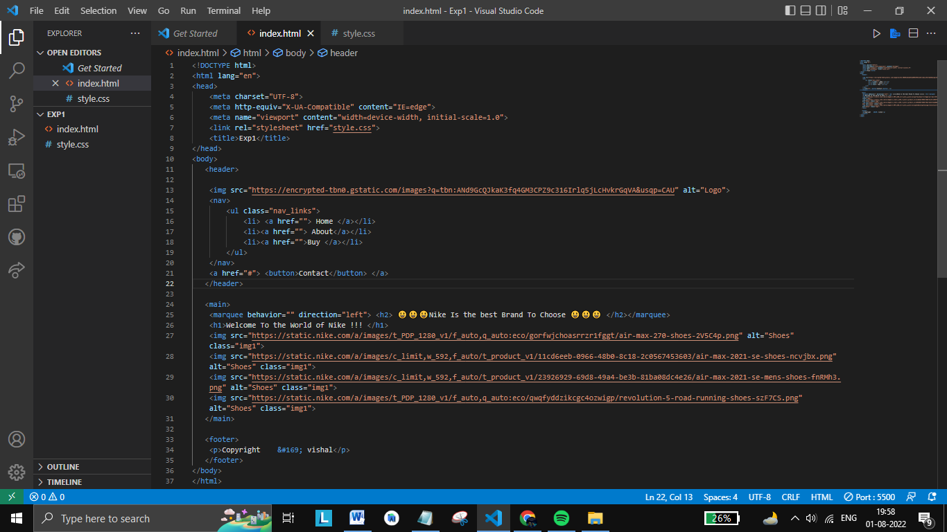

**CSS Code :**

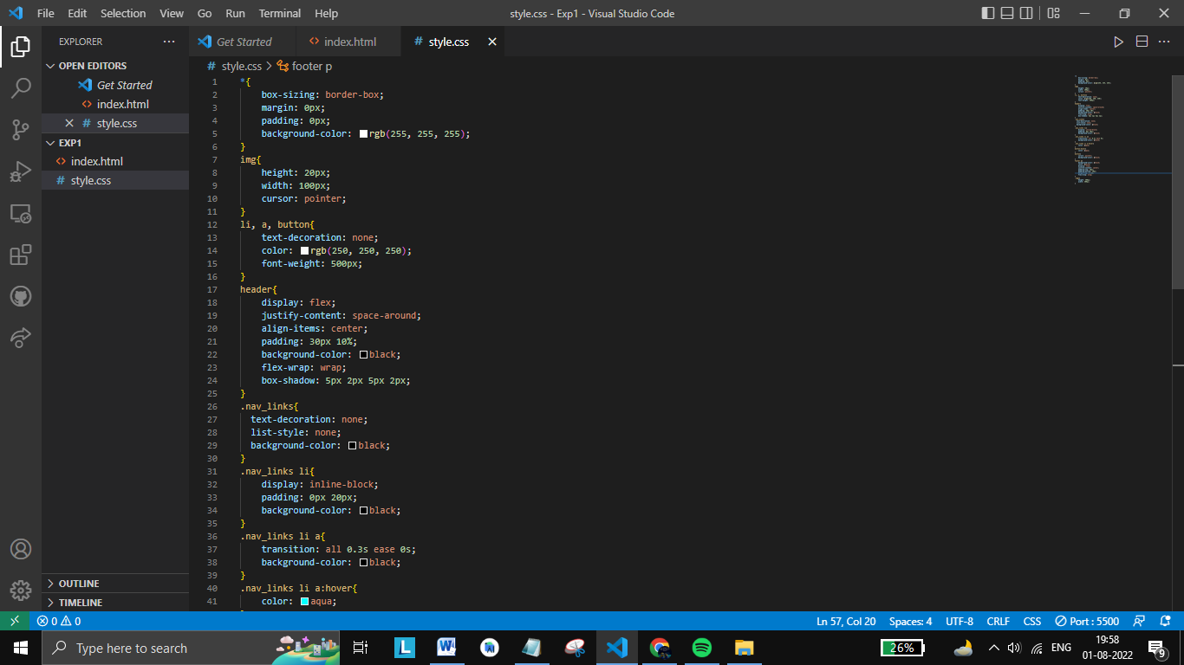

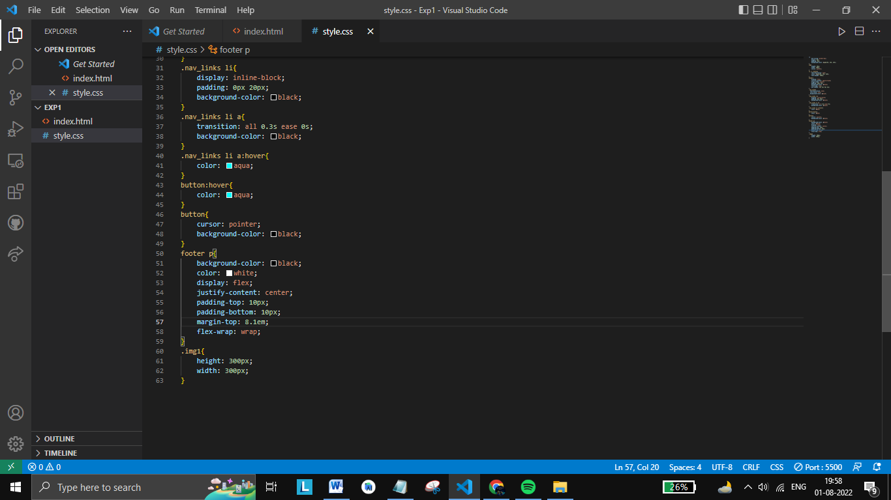

**Output :**

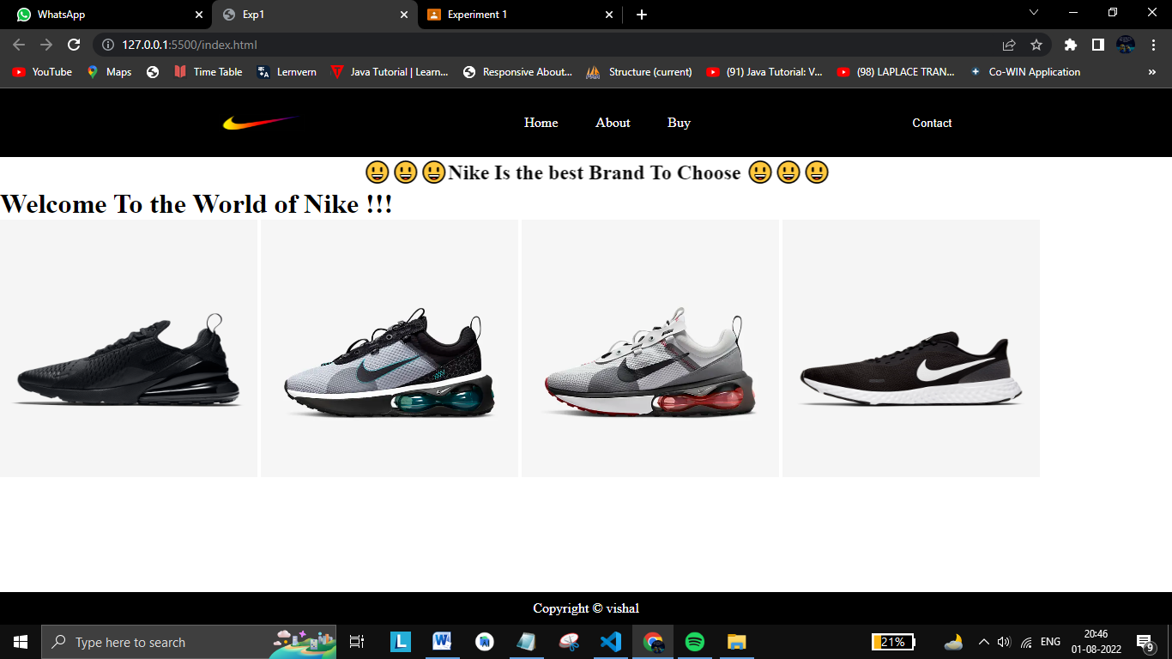

**Conclusion :** Thus, we used HTML tags to build our web page.